# INDUSTRY 4.0

Industry 4.0 is related to smart manufacturing industries; the number 4.0 represents the fourth industrial revolution.

The first revolution in the industries took place with the development of the mechanization, steam power and hydro power systems.

The second revolution originated from the mass production technologies and assembly lines manufacturing.

The third revolution came with the development of IC, electronics circuits, and IT system, and the fourth industrial revolution is connected to the cyber physical system and artificial intelligence(Portuguez and Bluteau, 2020).

# INDUSTRY 4.0 TECHNOLOGIES

Generally, industry 4.0 is the latest technology which would be implemented in the manufacturing industry to make it more intelligent and efficient. This revolution is basically the fully automation in the industry plus the exchange of data in the different processes and manufacturing machines(Radke, Dang and Tan, 2020). This is very broad field in the industry, which includes the number of fields which helps in the manufacturing industry to become more automatic and efficient.

Some of the fields are listed below;

1. **The industrial internet of things (IOT)**

The internet of things is the building block for smart manufacturing industries. In this technology, every manufacturing machine is equipped with sensors and all the sensors are connected through IP addresses which enabled every machine to communicate with each other. Thus, we can collect data, which must be analyzed and used for the betterment of the industries(Lampropoulos, Siakas and Anastasiadis, 2019).

1. **Cyber-security**

As far as there is an IOT based manufacturing systems, so it is important to keep the manufacturing system secure from the malware attach, which is exposed to the new entry path for the malware attacks(Mullet, Sondi and Ramat, 2021).

1. **Cloud computing**

Now a days we use data science in every field, from the education system to hospitals to food business and to the industries. For smart manufacturing, there must be a balance among the supply chain, production, sales and distribution, and services. Cloud computing can help(Dogo *et al.*, 2019).

1. **Digital twin**

There is always a waiting time that is wasted in every manufacturing industry, when a single machine is broken or becomes out of order. There is a replica of every process to reduce waiting time, when a machine becomes out of order. This is done due to the IoT sensors, devices which read the data and automatically make a decision(Guo *et al.*, 2020).

1. **Autonomous robotics**

With the development of robotic technology, and collaborative robotics, the minimum human interaction is allowed in smart manufacturing, which perform various difficult tasks in minimum time taken with full efficiency. Robotics tasks varies from scanning inventories, autonomous robots, which helps in pick and place, machining, painting etc.(Priya and Malhotra, 2020).

1. **Artificial intelligence**

AI is used in manufacturing industries not just on the factory floor but also to the business units, supply chain, production etc. which makes the industries the most intelligent(Peres *et al.*, 2020).

# ROLE OF ROBOTICS IN INDUSTRY 4.0

Robotic automation provides services that a robot can perform instead of human labor. Automation can be accomplished by updating software in robots or by employing artificial intelligence (AI) to conduct efficient, repetitive activities(Ribeiro *et al.*, 2021). In context of robotics in industry there are three types:

* Industrial robotics
* Collaborative robotics
* Service robotics

For the Industry 4.0 revolution, every discipline of robots is equally important. However, because close interaction between man and robot is feasible at the same time, collaborative robots are in high demand in today's period. It is vital to consider a complicated task with a number of aspects impacting the performance of production activities in order to have a more efficient and safe interaction between a human operator and a robot(Galin and Meshcheryakov, 2019).

When CNC machines are in use and potentially dangerous, a robot can load and unload them. If done on a regular basis, they can also be a great source of efficiency and reduced downtime. Robots have long been used in the automotive industry, but they are increasingly being used in a wide range of fields(Robotics, 2007). The development of robots and products is a natural fit. In today's production world, robotics is critical. Every operation seeking for optimal performance, protection, and competitive advantage should include automated manufacturing technologies as a vital component. Production robotics automate routine activities, lowering error margins to acceptable levels and allowing people to focus on the company's more profitable areas.

**TRACKING REQUIRED TRAJECTORY**

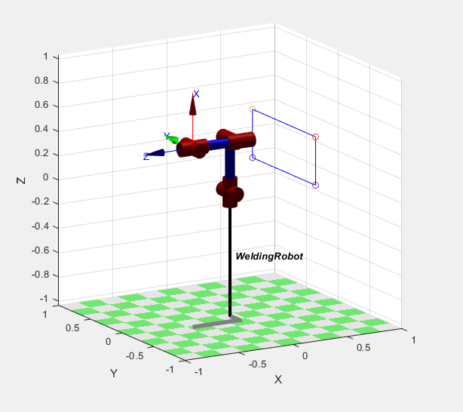

**FRAME ASSIGNED TO THE ROBOT JOINTS**

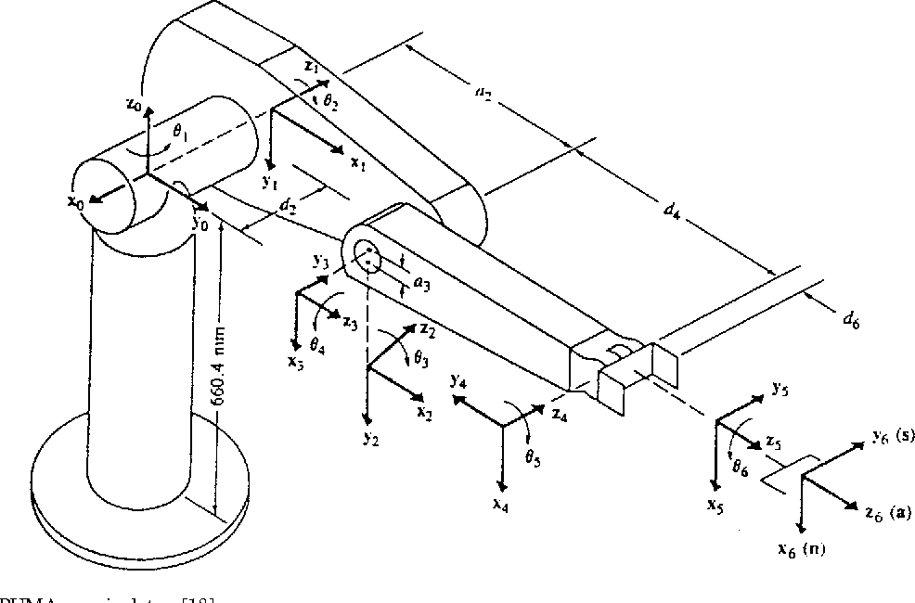

**DH PARAMETER OF THE ROBOT**

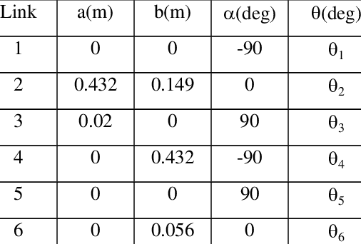

**Joints limits of the robot**

$$-{160}^{0}≤θ_{1}≤ {160}^{0} \\ -{45}^{0}≤θ_{2}≤ {225}^{0}$$

$$-{225}^{0}≤θ_{3}≤ {45}^{0}$$

$$-{110}^{0}≤θ_{4}≤ {170}^{0}$$

$$-{100}^{0}≤θ_{5}≤ {100}^{0}$$

$$-{266}^{0}≤θ_{6}≤ {266}^{0}$$

**DESIGN OF THE CONTROLLER FOR ROBOT**

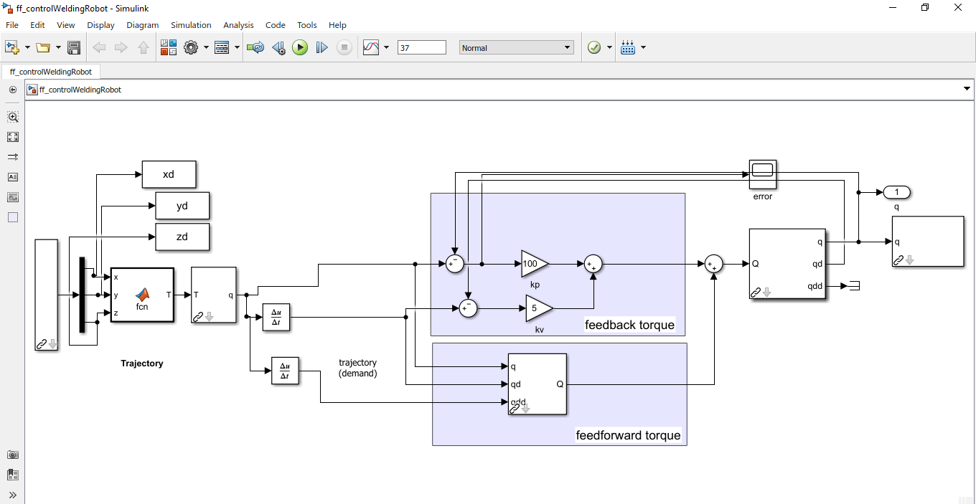

This controller needs to be tuned according to the trajectory tracking behavior. Currently the robot is having higher overshoots and thus the robot needs to be tuned by decreasing the proportional gain and increasing the derivative gains.

For the nonlinear behavior, we have to design adaptive controller so that the robot adapts its gain accordingly for the better trajectory tracking, and the hectic process of manually tuning the gains will be eliminated.

**Reference:**

Dogo, E. M. *et al.* (2019) ‘Taking cloud computing to the extreme edge: A review of mist computing for smart cities and industry 4.0 in africa’, *EAI/Springer Innovations in Communication and Computing*, pp. 107–132. doi: 10.1007/978-3-319-99061-3_7.

Galin, R. and Meshcheryakov, R. (2019) ‘Automation and robotics in the context of Industry 4.0: The shift to collaborative robots’, *IOP Conference Series: Materials Science and Engineering*, 537(3), pp. 0–5. doi: 10.1088/1757-899X/537/3/032073.

Guo, D. *et al.* (2020) ‘A framework for personalized production based on digital twin, blockchain and additive manufacturing in the context of Industry 4.0’, *IEEE International Conference on Automation Science and Engineering*, 2020-August(September), pp. 1181–1186. doi: 10.1109/CASE48305.2020.9216732.

Lampropoulos, G., Siakas, K. and Anastasiadis, T. (2019) ‘Internet of Things in the Context of Industry 4.0: An Overview’, *International Journal of Entrepreneurial Knowledge*, 7(1), pp. 4–19. doi: 10.2478/ijek-2019-0001.

Mullet, V., Sondi, P. and Ramat, E. (2021) ‘A Review of Cybersecurity Guidelines for Manufacturing Factories in Industry 4.0’, *IEEE Access*, 9, pp. 23235–23263. doi: 10.1109/ACCESS.2021.3056650.

Peres, R. S. *et al.* (2020) ‘Industrial Artificial Intelligence in Industry 4.0 -Systematic Review, Challenges and Outlook’, *IEEE Access*, pp. 220121–220139. doi: 10.1109/ACCESS.2020.3042874.

Portuguez, V. and Bluteau, D. R. (2020) ‘COMPOSTOS [ NN ] N NO VOCABULARIO PORTUGUEZ , E LATINO ... DE BLUTEAU ( SÉC . XVIII ) [ NN ] N COMPOUNDS IN THE BLUTEAU ’ S VOCABULARIO PORTUGUEZ , E LATINO ( 18TH CENTURY ) Victória TRIEBIG Antonia Vieira dos SANTOS Universidade Federal da Bahia , Brasil’, (2016).

Priya, B. and Malhotra, J. (2020) ‘5GAuNetS: an autonomous 5G network selection framework for Industry 4.0’, *Soft Computing*. Springer Berlin Heidelberg, 24(13), pp. 9507–9523. doi: 10.1007/s00500-019-04460-y.

Radke, A. M., Dang, M. T. and Tan, W. K. A. (2020) ‘Using robotic process automation (RPA) to enhance item master data maintenance process’, *Logforum*, 16(1), pp. 129–140. doi: 10.17270/J.LOG.2020.380.

Ribeiro, J. *et al.* (2021) ‘Robotic Process Automation and Artificial Intelligence in Industry 4.0 - A Literature review’, *Procedia Computer Science*. Elsevier B.V., 181(2019), pp. 51–58. doi: 10.1016/j.procs.2021.01.104.

Robotics, S. (2007) ‘and Manuel Armada’, (March), pp. 90–103.